

JAVA PROJECT REPORT ON
PROJECT TITLE:
SECURE USER LOGIN AND AUTHENTICATION SYSTEM WITH PASSWORD VALIDATION

Submitted by
YOUR NAME: PAVITHRA S
YOUR REGISTER NO: 25BCS041

Under the Guidance of
Trainer Name: Dr. BOOPALAN SUNDARAMOORTHY
Technical Trainer
Technical Department, KG College of Arts and Science

Academic Year: 2025 – 2026
APRIL 2026
Semester: 11

DECLARATION
I hereby declare that the project entitled [SECURE USER LOGIN AND AUTHENTICATION STSTEM WITH PASSSWORD VALIDATION] submitted in partial fulfilment of the requirements for the
[JAVA PROGRAMMING] is a record of my original work carried out under the guidance of [Dr. BOOPALAN SUNDARAMOORTHY], Technical Trainer, Technical Department, KG College of Arts and Science.
I further declare that this project has not been submitted previously, either in part or in full, for the award of any degree, diploma, or other similar title, at this or any other institution.
I have acknowledged all sources of information used in this project wherever applicable.

April 2026
Coimbatore

______PAVITHRA S___________ (Your Name)

CERTIFICATE
This is to certify that the project entitled [SECURE USER LOGIN AND AUTHENTICATION STSTEM WITH PASSSWORD VALIDATION] is a bona fide work carried out by [PAVITHRA S] [BSC CS],
[COMPUTER SCIENCE DEPARTMENT] KG College of Arts & Science,
in partial fulfilment of the requirements for the course [JAVA PROGRAMMING].
This project has been completed under my supervision and guidance during the academic period April 2026.

Place: COIMBATORE
Date:

Submitted for the Viva-Voce Examination held on __________________________________

Guide: Head of the Department
(Technical Trainer, KGCAS) (Technical Head, KGCAS)

______________________ _______________________

TABLE OF CONTENTS
S. No. | Topics | Page. No.
1 | Introduction
1.1 | Objective
1.2 | Overview
1.3 | Features
2 | Program Analysis
2.1 | Problem Definition
2.2 | Project Overview
2.3 | Scopes and Limitations
3 | System Design
3.1 | Modules
4 | Methodology
4.1 | Problem Analysis
4.2 | System Design
4.3 | Program Development
4.4 | Testing and Validation
4.5 | Result and Documentation
4.6 | Algorithm
4.7 | Flowchart
5 | Source Code
6 | Input and Output Screens
7 | Discussion and Conclusion
7.1 | Discussion
7.2 | Conclusion
8 | References

ABSTRACT

The Secure User Login and Authentication System with Password Validation is a Java-based application designed to provide secure access control for users. In many systems, weak authentication mechanisms can lead to unauthorized access and security vulnerabilities.

This project aims to develop a secure login system that validates user credentials such as username and password. The system ensures that passwords meet security requirements such as minimum length, uppercase letters, numbers, and special characters.

The application allows users to register, login, and verifies credentials using authentication logic. It also restricts access after multiple failed login attempts, improving system security.

This project uses Core Java concepts like classes, loops, conditions, and exception handling. It demonstrates the importance of authentication and validation in software security.

INTRODUCTION

In today’s digital era, security plays a vital role in protecting user data and system resources. Most applications require users to log in using credentials such as a username and password. However, weak authentication systems can lead to unauthorized access, data breaches, and cyber threats.

A Secure User Login and Authentication System with Password Validation is designed to ensure that only authorized users can access the system. This system verifies user credentials during login and applies password validation rules to enforce strong security standards. Password validation includes checks such as minimum length, use of uppercase and lowercase letters, numbers, and special characters.
The system also enhances security by limiting the number of login attempts. If a user enters incorrect credentials multiple times, the account may be temporarily locked to prevent unauthorized access. This reduces the risk of brute-force attacks.

This project is developed using Java programming and demonstrates the implementation of authentication and validation techniques using core programming concepts such as loops, conditional statements, and functions. The system can be implemented as a console-based or GUI-based application.

The main goal of this project is to provide a secure, reliable, and user-friendly login mechanism while demonstrating the importance of authentication and password security in real-world application
1.1 OBJECTIVES
The main objectives of the Secure User Login and Authentication System are:
To develop a secure login system using Java
To implement user authentication using username and password
To validate passwords based on security rules
To prevent unauthorized access to the system
To limit login attempts for enhanced security
To demonstrate the use of core Java programming concepts
To create a simple and user-friendly authentication system
1.2 OVERVIEW
The Secure User Login and Authentication System is a Java-based application that provides a secure platform for user authentication. The system allows users to register by creating a username and password, which are then stored for future login.
During login, the system verifies the entered credentials with the stored data. If the credentials match, access is granted; otherwise, the user is denied access. The system also checks whether the password meets required validation rules before accepting it.
The application is designed as a menu-driven system where users can perform actions such as registration and login. It ensures that only valid and authorized users can access the system.
This system can be implemented as a console-based application or enhanced into a graphical user interface using Java Swing.

1.3 FEATURES
The Secure User Login and Authentication System includes the following features:
User Registration – Allows users to create a new account with a username and password
Secure Login – Authenticates users based on stored credentials
Password Validation – Ensures passwords meet security requirements (length, uppercase, numbers, special characters)
Limited Login Attempts – Restricts the number of failed login attempts to enhance security
Error Handling – Displays appropriate messages for invalid inputs or login failures
User-Friendly Interface – Simple and easy-to-use system for users
Security Enhancement – Prevents unauthorized access and improves system protection

2. PROGRAM ANALYSIS
Program analysis is an important phase in software development where the problem is studied carefully and system requirements are identified. It helps in understanding how the system should function and what features are needed to solve the problem effectively.
In this project, the focus is on analysing the need for a secure login system. Many existing systems lack proper authentication and password validation, which leads to security vulnerabilities. Therefore, this system is designed to provide a secure method for user login and access control.
The analysis phase identifies the issues in existing systems and proposes a solution using a secure authentication mechanism with password validation. It ensures that only authorized users can access the system and improves overall security.
2.1 PROBLEM DEFINITION
In many applications, user authentication is not implemented securely, leading to several problems such as:
Weak passwords that are easy to guess
Lack of proper validation rules
Unlimited login attempts
Unauthorized access to sensitive data
Increased risk of hacking and data breaches
Manual or poorly designed login systems fail to provide adequate protection for user information. Attackers can easily exploit these weaknesses to gain access to the system.
Therefore, there is a need for a secure login system that:
Enforces strong password rules
Validates user credentials
Restricts multiple failed login attempts
Prevents unauthorized access
The Secure User Login and Authentication System with Password Validation is designed to address these issues by providing a reliable and secure authentication mechanism.
2.2 PROJECT OVERVIEW
The Secure User Login and Authentication System is a Java-based application developed to provide secure access control using authentication and password validation techniques.
The system allows users to:
Register with a username and password
Log in using valid credentials
Access the system only after successful authentication
During registration, the system validates the password based on predefined security rules such as minimum length and character requirements. During login, the system compares the entered credentials with stored data.
The system also includes a security feature that limits the number of login attempts. If the user enters incorrect credentials multiple times, the account is locked to prevent unauthorized access.
This project is implemented using Core Java concepts and can be developed as either a console-based application or a GUI application using Java Swing.
2.3 SCOPE AND LIMITATIONS
Scope
The scope of the Secure User Login and Authentication System includes:
Providing secure user authentication
Validating passwords using security rules
Restricting unauthorized access
Demonstrating authentication concepts in Java
Useful for small applications and learning purposes
The system can be applied in:
Educational projects
Small software applications
Basic login systems
Limitations
The limitations of this system include:
No database integration (stores data temporarily)
Supports only basic authentication
No password encryption in basic version
Limited to single-user environment
Does not support advanced security features like OTP or biometric authentication

3. SYSTEM DESIGN
System design is the phase where the overall structure of the system is planned before implementation. It defines how the system will work, how different components interact, and how data flows within the system.
In the Secure User Login and Authentication System with Password Validation, the system is designed as a simple and secure application that handles user registration, password validation, and login authentication.
The system follows a modular approach, where each module is responsible for a specific function. This makes the system easy to understand, develop, and maintain.
3.1 MODULES
The system is divided into the following main modules:
1. User Registration Module
This module allows new users to register into the system.
Functions:
Accepts username from the user
Accepts password from the user
Sends password to validation module
Stores valid user credentials
This module ensures that only valid passwords are accepted during registration.
2. Password Validation Module
This module checks whether the entered password meets security requirements.
Validation Rules:
Minimum 8 characters
At least one uppercase letter
At least one lowercase letter
At least one number
At least one special character
If the password does not meet these conditions, the system rejects it and asks the user to re-enter a valid password.
3. Login Module
This module handles the login process.
Functions:
Accepts username and password
Compares input with stored credentials
Sends data to authentication module
This module acts as the entry point for accessing the system.
4. Authentication Module
This module verifies whether the entered credentials are correct.
Functions:
Matches username and password
Grants access if correct
Denies access if incorrect
This ensures that only authorized users can log in.
5. Security Control Module
This module enhances system security.
Functions:
Limits login attempts (e.g., 3 attempts)
Displays warning messages
Locks account after multiple failures
This prevents brute-force attacks and unauthorized access.
6. User Interface Module
This module provides interaction between the user and the system.
Functions:
Displays messages and prompts
Accepts user input
Shows login success or failure messages
The interface is simple and user-friendly.
System Workflow (Simple Explanation)
User registers with username and password
Password is validated
Credentials are stored
4. METHODOLOGY
Methodology describes the step-by-step process followed to develop the Secure User Login and Authentication System with Password Validation. It explains how the problem is analyzed, how the system is designed, implemented, tested, and documented.
The development of this system follows a structured approach to ensure security, accuracy, and proper functionality.
The main stages involved are:
Problem Analysis
System Design
Program Development
Testing and Validation
Result and Documentation
4.1 PROBLEM ANALYSIS
In this phase, the existing issues related to login systems are studied carefully.
The following problems were identified:
Weak password systems that are easy to guess
Lack of proper password validation rules
Unlimited login attempts leading to security risks
Unauthorized access to sensitive information
Absence of proper authentication mechanisms
Based on these issues, the requirement for a secure login system was identified. The system must validate passwords and authenticate users before granting access.

4.2 SYSTEM DESIGN
In this stage, the structure of the system is planned before coding.
The system is divided into different modules such as:
Registration Module
Password Validation Module
Login Module
Authentication Module
Security Control Module
Each module performs a specific function, making the system organized and easy to develop.
The workflow of the system is also designed to ensure proper execution of login and validation processes.
4.3 PROGRAM DEVELOPMENT
In this phase, the system is implemented using Java programming language.
The development includes:
Writing code for user registration
Implementing password validation logic
Creating login and authentication functionality
Handling user inputs and outputs
Adding security features like limited login attempts
Core Java concepts used:
Classes and Objects
Conditional Statements (if-else)
Loops (while loop)
Methods
String handling
4.4 TESTING AND VALIDATION
Testing ensures that the system works correctly and meets all requirements.
Different test cases are used to validate the system:
Test Case
Expected Result
Valid password
Accepted
Invalid password
Rejected
Correct login
Access granted
Wrong password
Error message
3 failed attempts
Account locked
Validation ensures that the password follows all required rules and prevents weak passwords.
4.5 RESULT AND DOCUMENTATION
After successful testing, the system produces correct and expected results.
The system:
Validates passwords successfully
Authenticates users correctly
Prevents unauthorized access
Locks account after multiple failed attempts
The results are documented with program output and screenshots for better understanding.

4.6 ALGORITHM
Algorithm for Secure Login System:
Start the program
Enter username for registration
Enter password
Validate password using rules
If password is valid, store credentials
Ask user to login
Enter username and password
Compare with stored credentials
If correct, display "Login Successful"
If incorrect, reduce attempt count
Repeat login until attempts reach zero
If attempts = 0, lock account
End program
4.7 FLOWCHART
You can draw this in your record (very important for marks):

Start
↓
Enter Username & Password (Registration)
↓
Validate Password
↓
Valid?
/ \
Yes No
| |
Store Re-enter Password
↓
Login
↓
Enter Username & Password
↓
Check Credentials
↓
Correct?
/ \
Yes No
| |
Access Attempts Left?
Granted ↓
Yes → Retry
No → Account Locked
↓
End

5. SOURCE CODE
The following Java program implements a Secure User Login and Authentication System with Password Validation. It includes user registration, password validation, login authentication, and security features such as limited login attempts.
JAVA PROGRAM
import java.util.Scanner;
public class SecureLoginSystem {
static String storedUsername;
static String storedPassword;
// Method to validate password
public static boolean isValidPassword(String password) {
if (password.length() < 8) {
System.out.println("Password must be at least 8 characters long.");
return fallse;
}
if (! password.matches(“. [A-Z].")) {
System.out.println("Password must contain at least one uppercase letter.");
return false;
}
if (! password. Matches (“. [a-z].")) {
System.out.println("Password must contain at least one lowercase letter.");
return false;
}
if (! password.matches (“. [0-9].")) {
System.out.println("Password must contain at least one number.");
return false;
}
if password. Matches ("[@#$%^&+=].”) {
System.out.println("Password must contain at least one special character.");
return false;
}
return true;
}
public static void main (String [] args) {
Scanner sc = new Scanner (System.in);
System.out.println("==== Secure Login System ====");
// Registration
System.out.print("Enter Username: ");
storedUsername = sc.nextLine();
while (true) {
System.out.print("Enter Password: ");
String password = sc.nextLine();
if (isValidPassword(password)) {
storedPassword = password;
System.out.println("Registration Successful! \n");
break;
} else {
System.out.println("Invalid Password! Try again.\n");
}
}
// Login System
int attempts = 3;

while (attempts > 0) {
System.out.print("Enter Username: ");
String username = sc.nextLine();
System.out.print("Enter Password: ");
String password = sc.nextLine();
if (username.equals(storedUsername)
&& password.equals(storedPassword)) {
System.out.println("\nLogin Successful!");
break;
} else {
attempts--;
System.out.println("Invalid Credentials! Attempts left: " + attempts);
}
}
if (attempts == 0) {
System.out.println ("\nAccount Locked due to multiple failed attempts.");
}
sc. close ();
}
}

CODE EXPLANATION

Is Valid Password () → checks password strength
stored Username & stored Password → store user data
while loop → ensures correct password during registration
attempts → limits login tries to 3
if condition → checks login credentials
Account locks after 3 failed attempts

KEY FEATURES IMPLEMENTED IN CODE

Password validation (length, uppercase, lowercase, number, special character)
User registration
Secure login authentication
Limited login attempts
Account locking system.

6. INPUT AND OUTPUT SCREENS

This section shows the execution of the Secure User Login and Authentication System with Password Validation. It includes user input and system output at different stages such as registration, login, and error handling.
==== Secure Login System ====
Enter Username: pavithra
Enter Password: Pavithra@123
Registration Successful!
Enter Username: pavithra
Enter Password: Pavithra@123
Login Successful!

==== Secure Login System ====
Enter Username: pavithra
Enter Password: Pavithra@123
Registration Successful!
Enter Username: Kavitha
Enter Password: Kavitha@123
Invalid Credentials! Attempts left: 2
Enter Username: Kavitha
Enter Password: Kavitha@123
Invalid Credentials! Attempts left: 1
Enter Username: Kavitha
Enter Password: Kavitha@123
Invalid Credentials! Attempts left: 0
Account Locked due to multiple failed attempts.

INPUT SCREEN:
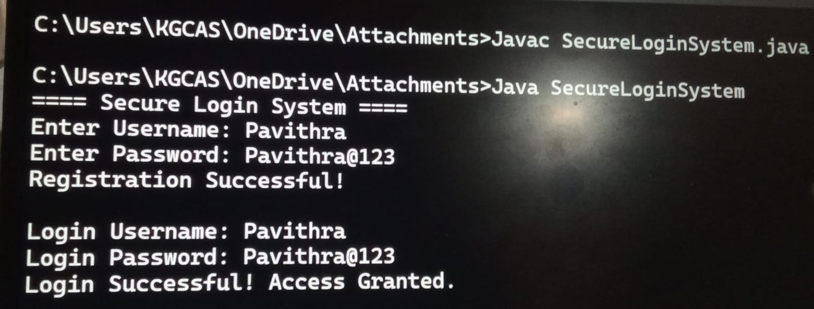

OUTPUT SCREEN:
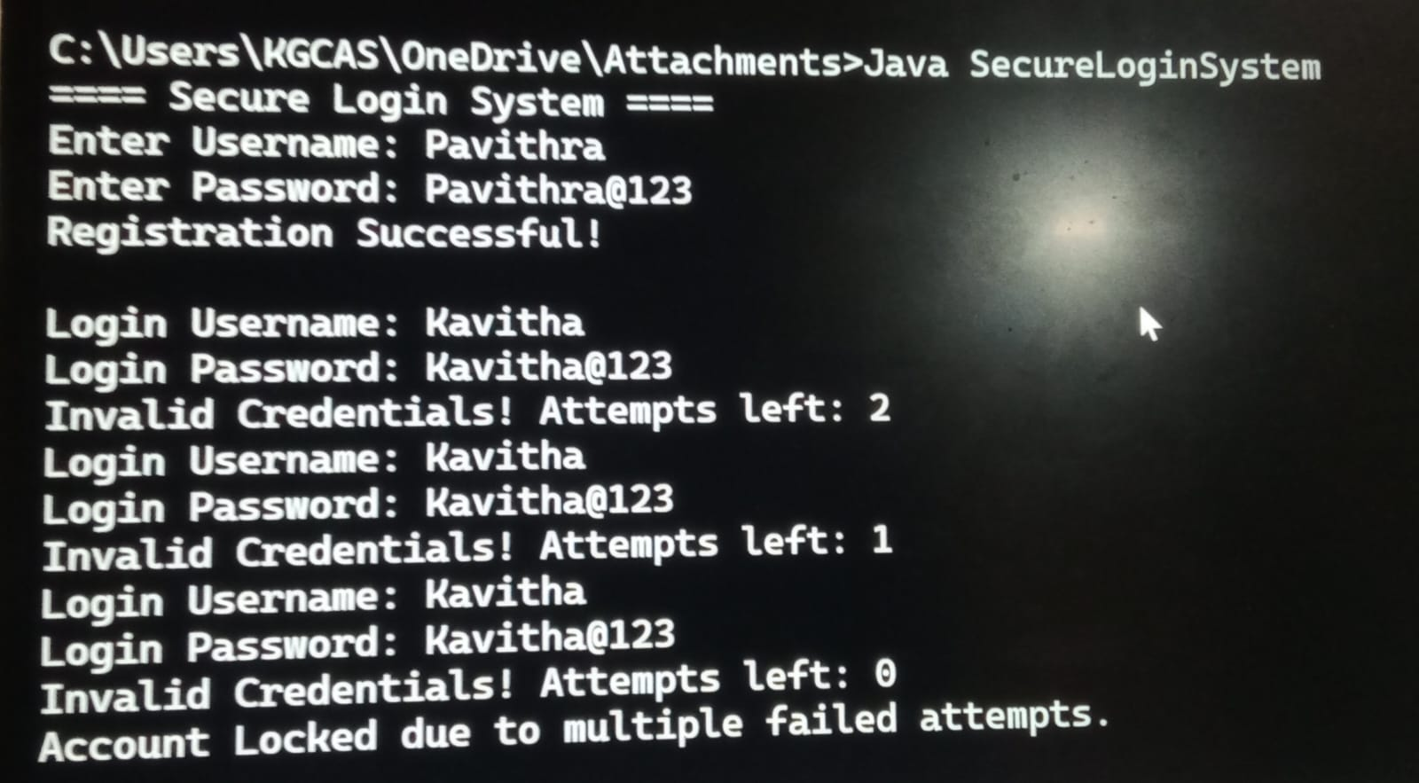

DISCUSSION AND CONCLUSION
7.1 DISCUSSION
The Secure User Login and Authentication System with Password Validation was developed to provide a simple and secure method for user authentication. The system ensures that only authorized users can access the application by verifying their username and password.
During the development process, various Core Java concepts such as conditional statements, loops, methods, and string handling were effectively used. The password validation mechanism plays an important role in improving security by enforcing rules such as minimum length, inclusion of uppercase and lowercase letters, numbers, and special characters.
The system was tested with different inputs to ensure proper functionality. It successfully handled both valid and invalid login attempts, displayed appropriate error messages, and restricted access after multiple failed attempts. This helps in preventing unauthorized access and reduces security risks.
Overall, the system demonstrates a basic but effective approach to implementing authentication and validation techniques in software applications.

7.2 CONCLUSION
The Secure User Login and Authentication System with Password Validation successfully demonstrates how a secure login mechanism can be implemented using Java programming.
The system validates user credentials, enforces strong password rules, and limits login attempts to enhance security. It ensures that only authorized users can access the system and reduces the risk of unauthorized access.
This project provides a clear understanding of authentication and password validation concepts and their importance in real-world applications. It also shows how Java can be used to develop simple and secure systems.
The system can be further improved by adding advanced features such as database connectivity, password encryption, graphical user interface (GUI), and multi-factor authentication.

8. REFERENCES
The following resources were used in the development of this project:
Books
Herbert Schildt – Java: The Complete Reference
Websites
https://www.oracle.com/java
https://www.geeksforgeeks.org
https://www.javapoint.com
https://www.w3schools.com

